Subject Level Analysis
Subject Reference Start Date/Time | 2014-01-02
Subject Reference End Date/Time | 2014-07-02
Age | 63
Sex | F

Vital Signs Analysis for Metabolic

Graphic
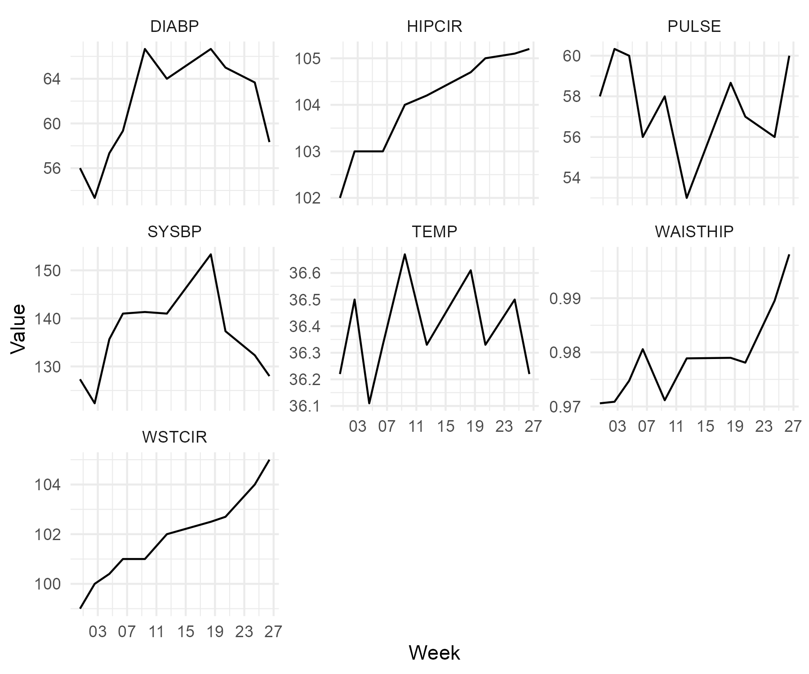

Table
Analysis Visit | Diastolic Blood Pressure (mmHg) | Hip Circumference (cm) | Pulse Rate (beats/min) | Systolic Blood Pressure (mmHg) | Temperature (C) | Waist to Hip Ratio | Waist Circumference (cm)
Baseline | 56.00 | 102.00 | 58.00 | 127.33 | 36.22 | 0.97 | 99.00
Week 2 | 53.33 | 103.00 | 60.33 | 122.33 | 36.50 | 0.97 | 100.00
Week 4 | 57.33 | 103.00 | 60.00 | 135.67 | 36.11 | 0.97 | 100.40
Week 6 | 59.33 | 103.00 | 56.00 | 141.00 | 36.33 | 0.98 | 101.00
Week 8 | 66.67 | 104.00 | 58.00 | 141.33 | 36.67 | 0.97 | 101.00
Week 12 | 64.00 | 104.20 | 53.00 | 141.00 | 36.33 | 0.98 | 102.00
Week 16 | 66.67 | 104.70 | 58.67 | 153.33 | 36.61 | 0.98 | 102.50
Week 20 | 65.00 | 105.00 | 57.00 | 137.33 | 36.33 | 0.98 | 102.70
Week 24 | 63.67 | 105.10 | 56.00 | 132.33 | 36.50 | 0.99 | 104.00
Week 26 | 58.33 | 105.20 | 60.00 | 128.00 | 36.22 | 1.00 | 105.00

